**Chapter 4 Review**

**Graph linear functions -** Student should be able to find any form of a linear equation given a point and a slope, 2 points, or an equation.

For the following equations, write the equation of the line in a) slope intercept form, b) standard form c) identify the slope x and y-intercepts and d) graph the function.

1. **(-3, 5) m = -2 2) (4, -3) m = -1/2**

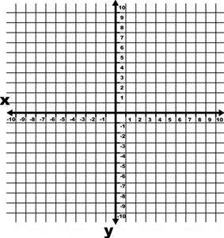 

1. **(-2,3) and (2,4) 4) 3x – 5y = 15**

 

1. **x – 5y = 10 6) 3x = 4y – 12**

 

**Equations of Parallel and Perpendicular Lines** - Students should be able to find the equation of parallel and perpendicular line. The line will be perpendicular or parallel line to a given equation/points/graph and contain a specific point.

1. Are the equations parallel, perpendicular or neither?

*a)* 2x – 3y = 12 *b)* 6y – 4x = 8 *c)* x – 2y = 4 *d)* 2y = -3x – 10 *e)* 10 – y = 2x



1. Given ABC is a quadrilateral, determine which sides are parallel or perpendicular.

A (-3,-4) B (1, -1) C (-2, 3) D (-6, 0)



1. Write an equation of a line that contains (10, -4) and is parallel to a line that passes through the points A (-2,3) and B(3,4) (write the equation in point-slope, slope-intercept and standard form)
2. Write an equation that contains (-6,2) and is perpendicular to a line that passes through X(-4,-3) and Y(4,1) (write the equation in point-slope, slope-intercept and standard form)
3. Write the equation of the perpendicular bisector to segment $\overline{GK}$ if G (-3, 4) and K (5, 6) in slope-intercept form.

**Transformations of linear functions -** Students should be familiar with the transformation vocabulary, mental graphing of changes to an equation and their effects on subsequent equations. Compare equations to the parent function and other functions.

1. List the following equations a –> g from steepest to flattest line.
2. 2x – 5y = 10 b) y =- ½ x – 3 c) 3x – 6y = 12 d) 3x – 4y = 8

e) y = (4/3)x – 5 f) f(x) = x g) g(x) = (3/2)x + 2 h) 3x – y = 2

1. List the transformation of y = -(7/2)x + 4 as compared to y = x linear parent function.
2. List the transformations of y = (1/3)x) – 5 as compared to y = x linear parent function.
3. A cell phone plan charges a flat fee of $50 and charges $15 each meg of data used. The company wants to increase revenue so it is considering raising the flat fee by $5 or the additional usage charge by $5. Which would net the company more money if someone uses 8 megs of data? How would the graphs be affected?
4. Write an equation in slope intercept form that is reflected, rotated 3 times steeper, and shifted up the y axis 4 units from y = -2x – 1.



**Inverse Linear Functions –** Students should be able to write equations of inverse functions, verify inverses graphically and algebraically.

1. Write and graph the inverse function of y = (2/3)x + 4 along with the graph of y = x.



y-1 = ____________________________

1. Write and graph the inverse function of 2x + 3y = 6 along with the graph of y = x.



y-1 = ____________________________

1. Verify algebraically if the following functions are inverses of each other:
2. $f\left(x\right)=\frac{1}{2}x-4$ and $f^{-1}\left(x\right)=2x+8$
3. $g\left(x\right)= -2x+4$ and $g^{-1}\left(x\right)=-\frac{1}{2}x-2$

**Scatter Plots, Correlation and Trend Lines –** Students should be able to determine correlation and causation between two quantities by making a scatter plot and interpreting the graph. Students should be able to draw the equation for the line of best fit by hand and using technology. Students will identify the strength of the correlation by the correlation coefficient.

1. Determine the type of correlation you would expect between the amount of gasoline in a gas tank and the number of miles driven.

Is there any causation relationship?

1. Given the following table of values, make a scatter plot of the data and determine the line of best fit in slope-intercept form.

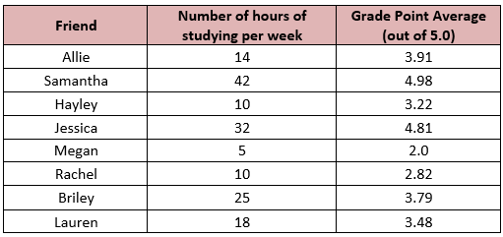

About how many hours would you expect someone who received 4.25 GPA spent studying?



